

**CAT342 Knowledge Management and Engineering**

**Assignment 1**

|  |  |  |
| --- | --- | --- |
| Name | Matrix Number | E-mail |
| Hwan Chin Yang | 137076 | chin_yang97@student.usm.my |
| Lee Chee Hooi | 137090 | cheehooi24@student.usm.my |
| Fung Jun Yin | 137070 | fungjunyin123@student.usm.my |

**Lecturer**

Assoc. Prof. Cheah Yu-N

Semester 1, Academic Session 2019/2020

School of Computer Sciences, Universiti Sains Malaysia 11800 USM, Penang, Malaysia

**1.0 Introduction**

In 2019, the world’s largest registry of pedigreed cats and known as the most prestigious pedigreed cat registering association in North America, Cat Fanciers' Association (CFA) recognizes 44 different types of cat breeds from all around the world. For novice animal lovers to research on cat breeds requires not only dedication but time as well because there are way too much cat breeds to look on. To make matter worse, every cat breed has their own distinctive features and characteristics.

Even if the novice animal lover is committed to research before adopting a cat, there are way too much cat breeds to look for. It will take a long time just to find a suitable cat breed for the novice animal lovers. However, with the help of expert system, anyone can find the most suitable cat breed for them in just a few minutes. In fact, the expert system in this assignment is designed for those who are new to the domain. This expert system will collect user’s preferences by accepting inputs from user. There will be a set of system generated multiple choice questions regarding the user’s preferences and the answers will be used to perform reasoning which will produce outputs in the form of an identification.

The expert system built for identification of cat breeds in this assignment was developed using Java programming language. Automated rule induction had been used to perform knowledge acquisition. The gathered knowledge is simplified and represented using decision trees. With decision tree, all the possible consequences of the decision can be fully shown which makes analyzing of the knowledge much easier.

**2.0 Knowledge Acquisition**

For knowledge acquisition, we chose to perform web-based knowledge elicitation approach to elicit all relevant knowledge from the web. The website that we used for the construction of the knowledge base is [www.catbreedslist.com](http://www.catbreedslist.com). The gathered knowledge is then transferred into induction table in Table 1.

This method is chosen due to the reason web is a good open source for eliciting knowledge via an anyplace and anytime collaborative-computing environment. The exposure to web provides a very convenient and efficient channel to access knowledge that would otherwise be costly to obtain, if not impossible. Thus, the availability of the web can alleviate a lot of the traditional reasons for the poor productivity of manual knowledge acquisition methods.

|  |  |  |  |  |  |  |
| --- | --- | --- | --- | --- | --- | --- |
| Cat Breeds | Shedding | Prone to health problems | Playfulness | Tendency to vocalize | Friendly | Easy to groom |
| Abyssinian | Low | Yes | High | Low | Yes | Yes |
| American Bobtail | High | No | High | Low | Yes | Yes |
| American Curl | High | No | High | Medium | Yes | Yes |
| American Shorthair | Medium | No | Low | Low | Yes | Yes |
| American Wirehair | Low | No | High | Low | Yes | Yes |
| Balinese | Medium | Yes | High | Low | Yes | Yes |
| Bengal Cats | Medium | Yes | High | Low | No | Yes |
| Birman | Medium | Yes | High | High | Yes | No |
| Bombay | Low | No | High | Medium | Yes | Yes |
| British Shorthair | Medium | No | Low | High | Yes | Yes |
| Burmese | Low | Yes | High | Medium | Yes | Yes |
| Burmilla | Medium | No | High | Low | No | Yes |
| Chartreux | High | No | Medium | Low | No | No |
| Chinese Li Hua | Medium | Yes | High | Medium | Yes | No |
| Colorpoint Shorthair | Low | Yes | High | Low | No | Yes |
| Cornish Rex | Low | No | High | Low | Yes | Yes |
| Cymric | High | Yes | High | Low | Yes | No |
| Devon Rex | Low | Yes | High | Medium | Yes | Yes |
| Egyptian Mau | Medium | No | High | Low | No | Yes |
| European Burmese | Low | Yes | High | Low | Yes | Yes |
| Exotic Shorthair | Low | Yes | High | High | No | Yes |
| Havana Brown | Medium | No | Medium | Low | No | Yes |
| Himalayan | High | Yes | Medium | Low | No | No |
| Japanese Bobtail | Medium | No | High | Low | Yes | Yes |
| Javanese | Medium | Yes | High | Low | Yes | Yes |
| Korat | Low | No | Medium | High | No | Yes |
| LaPerm | Low | No | High | Low | Yes | Yes |
| Maine Coon | High | No | High | Medium | No | Yes |
| Manx | Medium | No | High | Medium | No | Yes |
| Nebelung | High | No | High | Low | No | No |
| Norwegian Forest | High | Yes | Medium | High | No | No |
| Ocicat | Low | Yes | High | Medium | Yes | Yes |
| Oriental | High | Yes | High | Low | Yes | Yes |
| Persian | High | Yes | Low | Low | No | No |
| Pixie-Bob | High | No | High | Low | Yes | No |
| Ragamuffin | High | No | Medium | Low | Yes | Yes |
| Ragdoll Cats | High | No | High | High | Yes | No |
| Russian Blue | Medium | No | Medium | Low | No | No |
| Savannah | Medium | No | High | Low | Yes | Yes |
| Scottish Fold | Medium | Yes | Medium | High | Yes | No |
| Selkirk Rex | High | No | High | Medium | Yes | No |
| Siamese Cat | Low | No | High | High | Yes | Yes |
| Siberian | High | No | High | Low | Yes | No |
| Singapura | Low | No | High | High | Yes | Yes |
| Snowshoe | Medium | No | High | Low | Yes | Yes |
| Somali | Medium | Yes | High | Low | Yes | No |
| Sphynx | Low | Yes | Medium | High | Yes | Yes |
| Tonkinese | High | Yes | High | Low | Yes | No |
| Turkish Angora | Low | No | High | Medium | Yes | Yes |

Table 1: Cat breed and its characteristics

Basically, the cat breeds are determined through 6 categories which is shedding, prone to health problems, playfulness, tendency to vocalize, friendly and easy to groom. For “shedding”, “playfulness” and “tendency to vocalize”, there will be 3 options, low, medium or high. Meanwhile, for “prone to health problems”, “friendly” and “easy to groom” only have 2 options which is yes or no.

**3.0 Knowledge Representation**

In knowledge representation, we use decision trees and decision rules to carry out for this expert system. It will divide the characteristics of the cat and concludes a cat breed based on the different characteristics of the cat that selected by the users.

**Decision Trees**

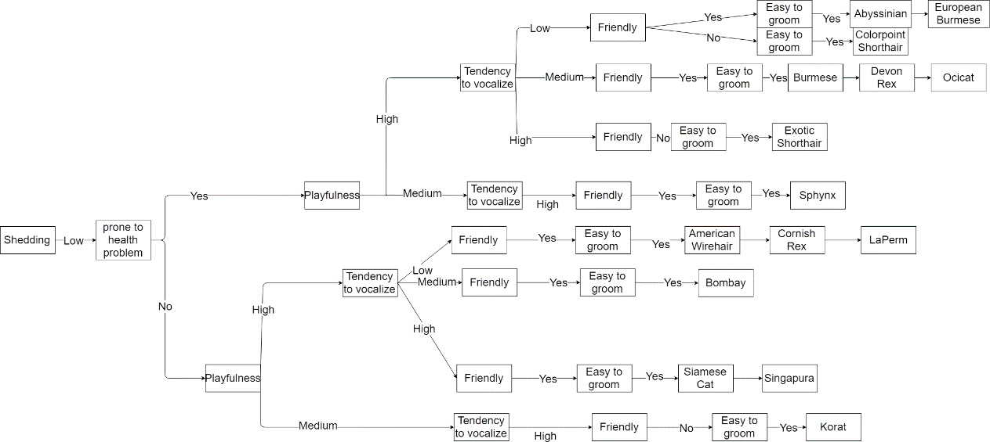

Diagram 1: The decision tree for the low shedding of the cat breed

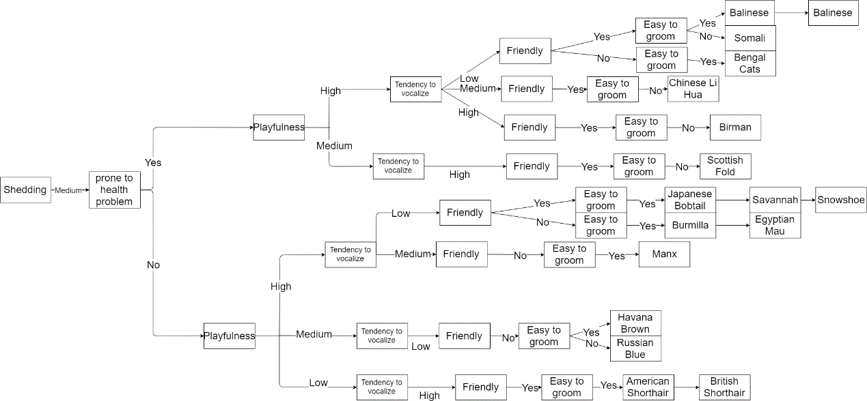

Diagram 2: The decision tree for the medium shedding of the cat breed

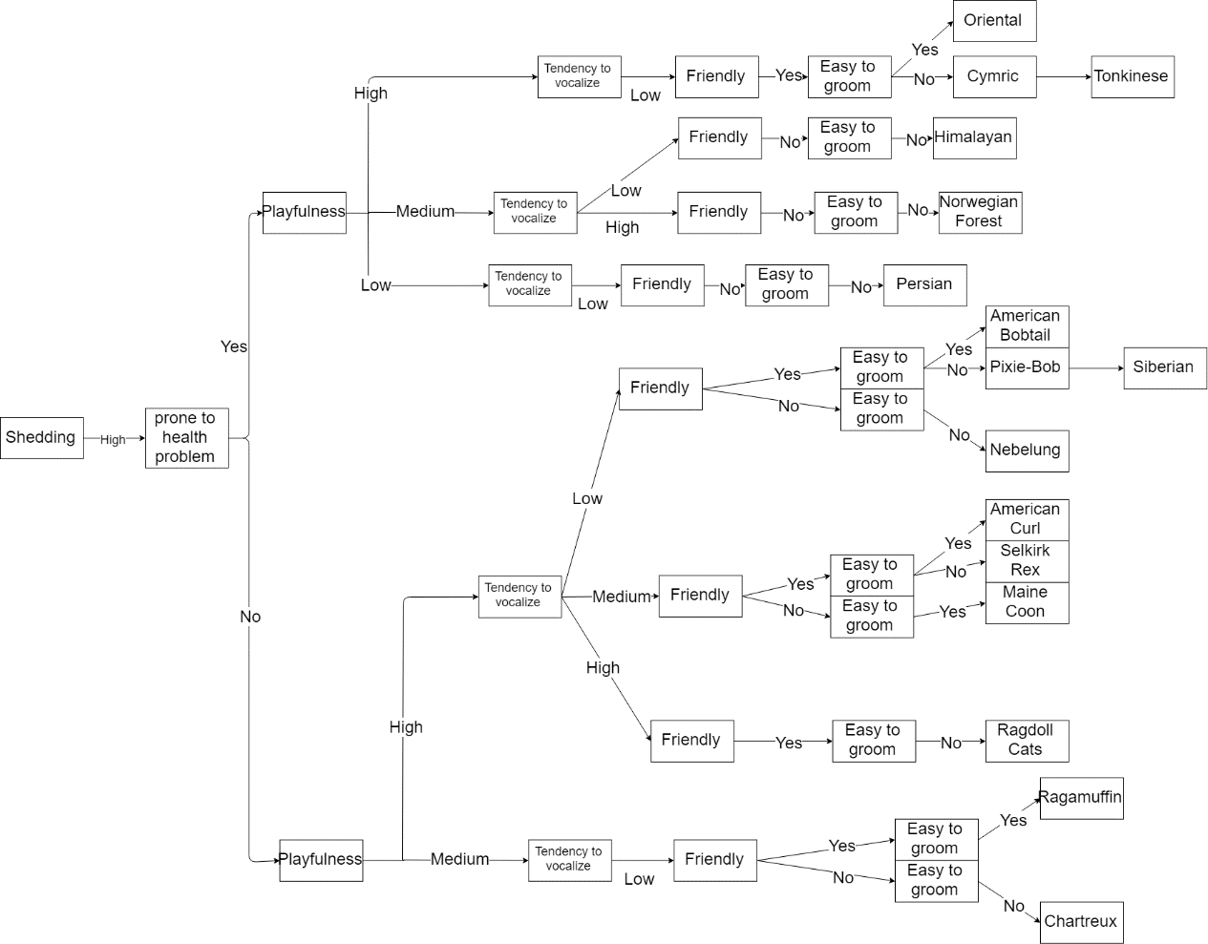

Diagram 3: The decision tree for the high shedding of the cat breed

**Decision Rules**

R1: IF the shedding of cat is low

AND will prone to health problem

AND it is more playful

AND it has low tendency to vocalize

AND it is friendly

AND it is easy to groom

THEN it is an Abyssinian.

R2: IF the shedding of cat is low

AND will prone to health problem

AND it is more playful

AND it has low tendency to vocalize

AND it is friendly

AND it is easy to groom

THEN it is a European Burmese.

R3: IF the shedding of cat is low

AND will prone to health problem

AND it is more playful

AND it has low tendency to vocalize

AND it is unfriendly

AND it is easy to groom

THEN it is a Colorpoint Shorthair.

R4: IF the shedding of cat is low

AND will prone to health problem

AND it is more playful

AND it has medium tendency to vocalize

AND it is friendly

AND it is easy to groom

THEN it is a Burmese.

R5: IF the shedding of cat is low

AND will prone to health problem

AND it is more playful

AND it has medium tendency to vocalize

AND it is friendly

AND it is easy to groom

THEN it is a Devon Rex.

R6: IF the shedding of cat is low

AND will prone to health problem

AND it is more playful

AND it has medium tendency to vocalize

AND it is friendly

AND it is easy to groom

THEN it is an Ocicat.

R7: IF the shedding of cat is low

AND will prone to health problem

AND it is more playful

AND it has high tendency to vocalize

AND it is unfriendly

AND it is easy to groom

THEN it is an Exotic Shorthair.

R8: IF the shedding of cat is low

AND will prone to health problem

AND it is playful

AND it has high tendency to vocalize

AND it is friendly

AND it is easy to groom

THEN it is a Sphynx.

R9: IF the shedding of cat is low

AND will not prone to health problem

AND it is more playful

AND it has low tendency to vocalize

AND it is friendly

AND it is easy to groom

THEN it is an American Wirehair.

R10: IF the shedding of cat is low

AND will not prone to health problem

AND it is more playful

AND it has low tendency to vocalize

AND it is friendly

AND it is easy to groom

THEN it is a Cornish Rex.

R11: IF the shedding of cat is low

AND will not prone to health problem

AND it is more playful

AND it has low tendency to vocalize

AND it is friendly

AND it is easy to groom

THEN it is a LaPerm.

R12: IF the shedding of cat is low

AND will not prone to health problem

AND it is more playful

AND it has medium tendency to vocalize

AND it is friendly

AND it is easy to groom

THEN it is a Bombay.

R13: IF the shedding of cat is low

AND will not prone to health problem

AND it is more playful

AND it has medium tendency to vocalize

AND it is friendly

AND it is easy to groom

THEN it is a Turkish Angora.

R14: IF the shedding of cat is low

AND will not prone to health problem

AND it is more playful

AND it has high tendency to vocalize

AND it is friendly

AND it is easy to groom

THEN it is a Siamese Cat.

R15: IF the shedding of cat is low

AND will not prone to health problem

AND it is more playful

AND it has high tendency to vocalize

AND it is friendly

AND it is easy to groom

THEN it is a Singapura.

R16: IF the shedding of cat is low

AND will not prone to health problem

AND it is playful

AND it has high tendency to vocalize

AND it is unfriendly

AND it is easy to groom

THEN it is a Korat.

R17: IF the shedding of cat is medium

AND will prone to health problem

AND it is more playful

AND it has low tendency to vocalize

AND it is friendly

AND it is easy to groom

THEN it is a Balinese.

R18: IF the shedding of cat is medium

AND will prone to health problem

AND it is more playful

AND it has low tendency to vocalize

AND it is friendly

AND it is easy to groom

THEN it is a Javanese.

R19: IF the shedding of cat is medium

AND will prone to health problem

AND it is more playful

AND it has low tendency to vocalize

AND it is friendly

AND it is difficult to groom

THEN it is a Somali.

R20: IF the shedding of cat is medium

AND will prone to health problem

AND it is more playful

AND it has low tendency to vocalize

AND it is unfriendly

AND it is easy to groom

THEN it is a Bengal Cats.

R21: IF the shedding of cat is medium

AND will prone to health problem

AND it is more playful

AND it has medium tendency to vocalize

AND it is friendly

AND it is difficult to groom

THEN it is a Chinese Li Hua.

R22: IF the shedding of cat is medium

AND will prone to health problem

AND it is more playful

AND it has high tendency to vocalize

AND it is friendly

AND it is difficult to groom

THEN it is a Birman.

R23: IF the shedding of cat is medium

AND will prone to health problem

AND it is playful

AND it has high tendency to vocalize

AND it is friendly

AND it is difficult to groom

THEN it is a Scottish Fold.

R24: IF the shedding of cat is medium

AND will not prone to health problem

AND it is more playful

AND it has low tendency to vocalize

AND it is friendly

AND it is easy to groom

THEN it is a Japanese Bobtail.

R25: IF the shedding of cat is medium

AND will not prone to health problem

AND it is more playful

AND it has low tendency to vocalize

AND it is friendly

AND it is easy to groom

THEN it is a Savannah.

R26: IF the shedding of cat is medium

AND will not prone to health problem

AND it is more playful

AND it has low tendency to vocalize

AND it is friendly

AND it is easy to groom

THEN it is a Snowshoe.

R27: IF the shedding of cat is medium

AND will not prone to health problem

AND it is more playful

AND it has low tendency to vocalize

AND it is unfriendly

AND it is easy to groom

THEN it is a Burmilla.

R28: IF the shedding of cat is medium

AND will not prone to health problem

AND it is more playful

AND it has low tendency to vocalize

AND it is unfriendly

AND it is easy to groom

THEN it is an Egyptian Mau.

R29: IF the shedding of cat is medium

AND will not prone to health problem

AND it is more playful

AND it has medium tendency to vocalize

AND it is unfriendly

AND it is easy to groom

THEN it is a Manx.

R30: IF the shedding of cat is medium

AND will not prone to health problem

AND it is playful

AND it has low tendency to vocalize

AND it is unfriendly

AND it is easy to groom

THEN it is a Havana Brown.

R31: IF the shedding of cat is medium

AND will not prone to health problem

AND it is playful

AND it has low tendency to vocalize

AND it is unfriendly

AND it is difficult to groom

THEN it is a Russian Blue.

R32: IF the shedding of cat is medium

AND will not prone to health problem

AND it is less playful

AND it has high tendency to vocalize

AND it is friendly

AND it is easy to groom

THEN it is an American Shorthair.

R33: IF the shedding of cat is medium

AND will not prone to health problem

AND it is less playful

AND it has high tendency to vocalize

AND it is friendly

AND it is easy to groom

THEN it is a British Shorthair.

R34: IF the shedding of cat is high

AND will prone to health problem

AND it is more playful

AND it has low tendency to vocalize

AND it is friendly

AND it is easy to groom

THEN it is an Oriental.

R35: IF the shedding of cat is high

AND will prone to health problem

AND it is more playful

AND it has low tendency to vocalize

AND it is friendly

AND it is difficult to groom

THEN it is a Cymric.

R36: IF the shedding of cat is high

AND will prone to health problem

AND it is more playful

AND it has low tendency to vocalize

AND it is friendly

AND it is difficult to groom

THEN it is a Tonkinese.

R37: IF the shedding of cat is high

AND will prone to health problem

AND it is playful

AND it has low tendency to vocalize

AND it is unfriendly

AND it is difficult to groom

THEN it is a Himalayan.

R38: IF the shedding of cat is high

AND will prone to health problem

AND it is playful

AND it has high tendency to vocalize

AND it is unfriendly

AND it is difficult to groom

THEN it is a Norwegian Forest.

R39: IF the shedding of cat is high

AND will prone to health problem

AND it is less playful

AND it has low tendency to vocalize

AND it is unfriendly

AND it is difficult to groom

THEN it is a Persian.

R40: IF the shedding of cat is high

AND will not prone to health problem

AND it is more playful

AND it has low tendency to vocalize

AND it is friendly

AND it is easy to groom

THEN it is an American Bobtail.

R41: IF the shedding of cat is high

AND will not prone to health problem

AND it is more playful

AND it has low tendency to vocalize

AND it is friendly

AND it is difficult to groom

THEN it is a Pixie-Bob.

R42: IF the shedding of cat is high

AND will not prone to health problem

AND it is more playful

AND it has low tendency to vocalize

AND it is friendly

AND it is difficult to groom

THEN it is a Siberian.

R43: IF the shedding of cat is high

AND will not prone to health problem

AND it is more playful

AND it has low tendency to vocalize

AND it is unfriendly

AND it is difficult to groom

THEN it is a Nebelung.

R44: IF the shedding of cat is high

AND will not prone to health problem

AND it is more playful

AND it has medium tendency to vocalize

AND it is friendly

AND it is easy to groom

THEN it is an American Curl.

R45: IF the shedding of cat is high

AND will not prone to health problem

AND it is more playful

AND it has medium tendency to vocalize

AND it is friendly

AND it is difficult to groom

THEN it is a Selkirk Rex.

R46: IF the shedding of cat is high

AND will not prone to health problem

AND it is more playful

AND it has medium tendency to vocalize

AND it is unfriendly

AND it is easy to groom

THEN it is a Maine Coon.

R47: IF the shedding of cat is high

AND will not prone to health problem

AND it is more playful

AND it has high tendency to vocalize

AND it is friendly

AND it is difficult to groom

THEN it is a Ragdoll Cats.

R48: IF the shedding of cat is high

AND will not prone to health problem

AND it is playful

AND it has low tendency to vocalize

AND it is friendly

AND it is easy to groom

THEN it is a Ragamuffin.

R49: IF the shedding of cat is high

AND will not prone to health problem

AND it is playful

AND it has low tendency to vocalize

AND it is unfriendly

AND it is difficult to groom

THEN it is a Chartreux.

**4.0 Inferencing**

The methods used in the inference engine of this expert system is deductive reasoning. Since this expert system requires user to input data via multiple choice questions and there are already tons of rules prepared, using deductive reasoning to work on inferencing seems to be the most suitable method. As a top down logic, deductive reasoning can generate conclusion based on the concordance of the rules and data provided.

In the inference engine, we implemented forward chaining which represents deductive reasoning to find the suitable cat breeds using the determined conditions and rules. Forward chaining is required in the inference engine to starts from known conditions and rules, then progresses towards a logical conclusion using the if-then statements or can be considered as antecedent and consequent. In layman’s terms, forward chaining will search all the possible conclusions based on the user input and rules from the knowledge base.

For instance, using the user input in the following for finding a cat breed.

Shedding = high, prone to health problems = yes, playfulness = high, tendency to vocalize = low, friendly = yes, easy to groom = yes

The inference engine will start inferring from “shedding = high” based on the rules and continue until the end of the input which is “easy to groom = yes”. Then, the system will print the name and the picture of the cat breeds. In this case, the inputs form user is exactly the same as the rules stated for the cat breed “oriental”. Thus, the output will be the picture of the cat breed “oriental”. If there is more than a cat breed concluded from the input then the system will show more than a cat breed.

**5.0 Discussion**

The expert system that we built can function well as it allows the novice cat lovers can easily understand and uses this system without any additional knowledge. The system allows the users to choose the answer that they prefer according to each question that has been asked.

In each question, there will be multiple choice answers and the users need to choose one answer from them and press search button to search for the cat breed. If there is a cat breed of the categories that is chosen by the users, it will show the cat breed with a picture of that cat and its name. If there is a cat breed of the categories that is not chosen by the users, it will not show the cat breed and prompt error to search for this breed.

Although the expert system can function well, it might be needing some improvement on it if we need to publish the expert system to the public users. It may be needing some attractive user interface to attract the users to use this system. Besides, it still lacks some description and information about the cat breed. It needs more time to research for the details of the cat breed so that the system can have a better information for the users.

**6.0 Conclusion**

In this expert system, we learnt how to apply the decision trees, rules and other knowledges that are suitable for the system. It is very important to choose the appropriate data structure for the rules and inferencing so that the expert system can be functioned well.

We use the web-based knowledge elicitation approach for the knowledge acquisition as it is open sources and can be easily to elicit the knowledge. For the knowledge representation, we use decision trees and decision rules to determine which categories of cat breed it falls to by the division of the characteristics of the cats. We use the deductive reasoning in this expert system because it can generate the conclusion itself based on the decision rules and the data that is provided.

In the nutshell, it is important that we apply knowledges in this cat breed expert system as it can benefits a lot of novice cat lovers and helps them to find for a cat breed that suit them as well.